myMesiniaga Portal User Guide

Document Version History

Date | Author | Version | Description of Change
17-09-2021 | Shafinaz Ismail | 1.0 | Created document for myMesiniaga Portal
Copyright © 2021 Mesiniaga Berhad
All rights reserved.
No part of this publication may be reproduced, stored in a retrieval system, or transmitted in any form or by any means, electronic, mechanical, photocopy, recording or otherwise without the prior written permission of Mesiniaga Berhad.
This document is the property of Mesiniaga Berhad and may not be disclosed to a third party.

Contents
Document Version History 1
Introduction 3
1. Access to myMesiniaga Portal 3
a. Login Page 3
b. Login Password 3
2. Welcome Page 4
3. Solutions 4
To view the Solutions offered by Mesiniaga 4
4. Report an Issue 5
To report an issue 5
5. Ask a question 5
To ask a general inquiries 5
6. Dashboard 6
a. Incident logged today 6
b. Outstanding P1 Incidents logged today 6
c. Incident Summary (All) 6
d. Incident Summary (this month) 6
e. To view List of Tickets 7
f. To download Report 7
g. Additional Tips: To convert PDF to Excel 7

Introduction
This user guide is intended for users who perform the following duties with myMesiniaga Portal:
- Report an issue
- View the ticket status via Dashboard

1. Access to myMesiniaga Portal

Login Page
To access the myMesiniaga Portal, open the web browser with the URL
https://mesiniaga.service-now.com/my.

Login Password
Please key in the username and password given and click Login.
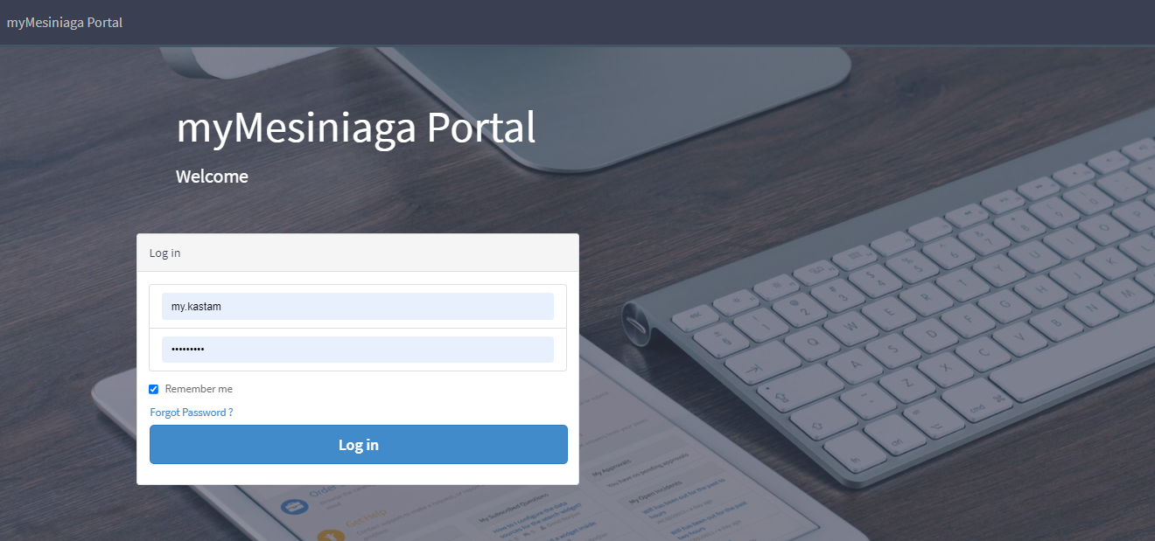

Welcome Page
There are 4 options available:
- Solutions (Catalog)
- Report an issue (Create a self-service ticket)
- Ask a question (General inquiries)
- Dashboard (View and download reports)
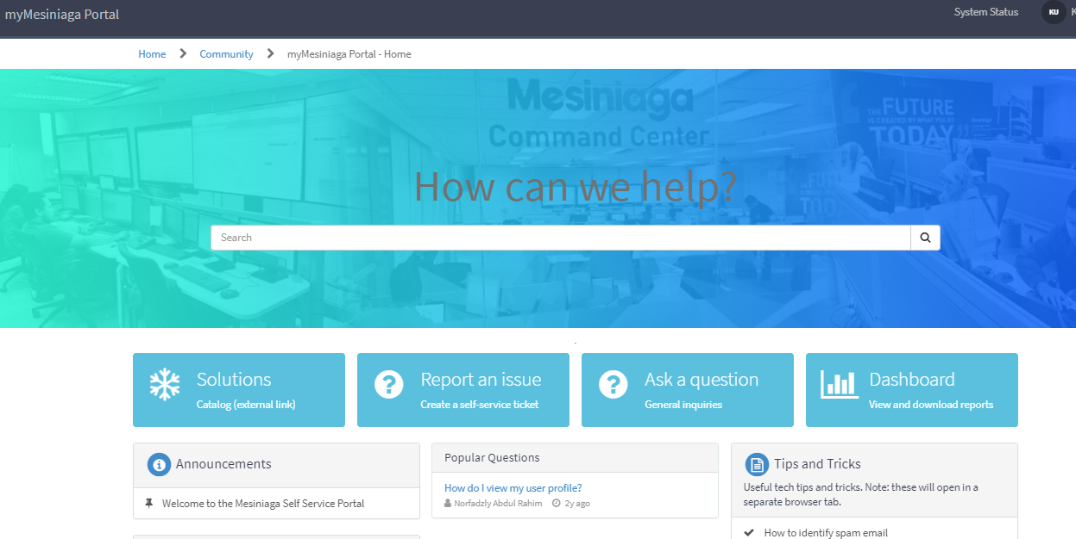

Solutions

To view the Solutions offered by Mesiniaga
Click on the ‘Solutions’ button, all Mesiniaga Products and Services will be displayed accordingly.

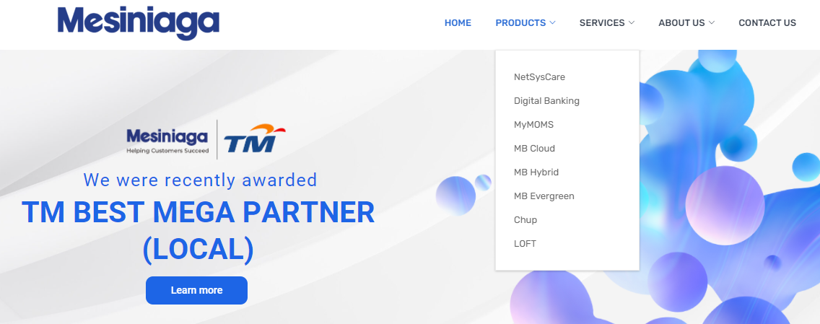

Report an Issue

To report an issue
- Click on the ‘Report an issue’ button, a request form will be displayed accordingly.
- Fill up all the necessary details and click ‘Add attachment’ should you wish to add any supporting documents.
- Click ‘Submit’ button.
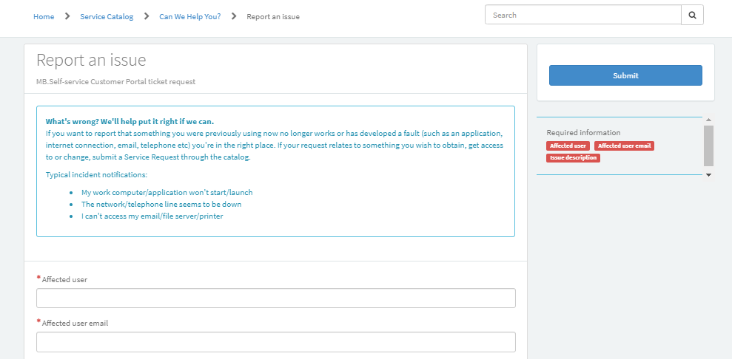

Ask a question

To ask general inquiries
- Click on the ‘Ask a question’ button, a form will be displayed accordingly.
- Fill up the question, the details and tag if any.
- Click ‘Post question’ button.
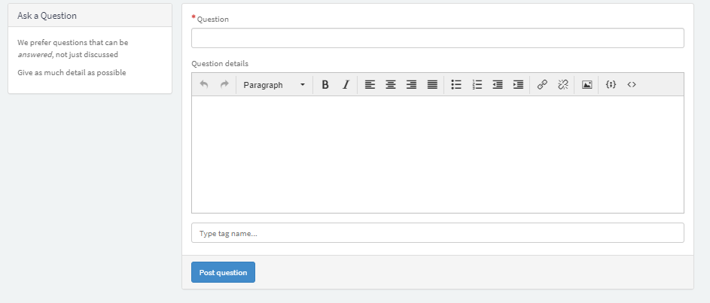

Dashboard

The dashboard includes:-

Incident logged today
This view shows the total no of Tickets logged for the day.

Outstanding P1 Incidents logged today
This view shows the total outstanding P1 Tickets for the day.

Incident Summary (All)
This view shows the Incident Summary for all tickets including:
- Total incidents created
- All Incidents still open
- All Incidents closed

Incident Summary (this month)
This view shows the Incident Summary for the current month including:
- Total incidents created
- Incidents still open
- Inclidents closed
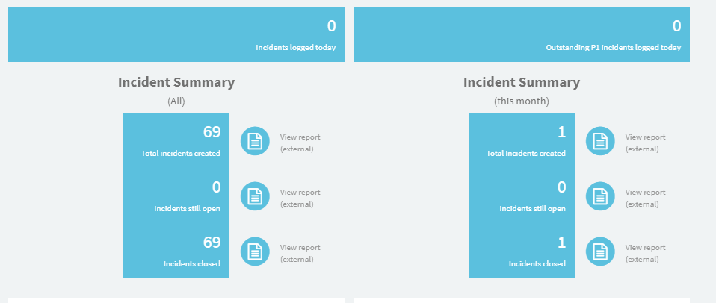

The ‘Incident Summary’ table has the following functions:
- To view List of Tickets
- Download Report

To view List of Tickets
- Click on the ‘View report (external) button.
This view shows the ticket’s details, such as Ticket Number, Created Date/Time, Resolved Date/Time, Ticket State, Branch,Affected User, Short Description, Priority, Category, Subcategory and remark under Close Notes.

To download Report
- Click on the ‘View report (external) button.
- Click on the ‘Click to Print’ icon.
- Click ‘Save’.
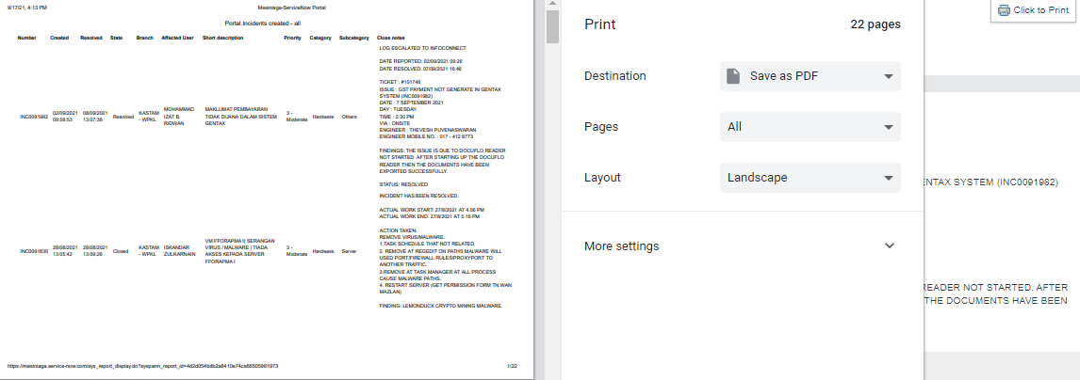

Additional Tips: To convert PDF to Excel
- Select the relevant PDF file.
- Open the file, press ctrl+A to select all.
- Press Ctrl+C to copy.
- Open a new excel file and press Ctrl+V to paste copied text.
- Save the excel file.
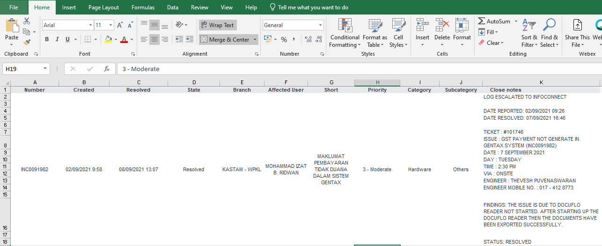

End of document

